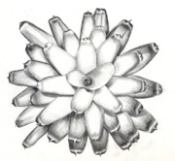
BROMELIAD FAIR

Hundreds of exotic bromeliads from beautiful to bizarre
Rare and unusual Tillandsias, colourful Neos and Guzmanias,
spectacular Vrieseas, dazzling Aechmeas...
Broms for all tastes!

Saturday/Sunday, October 10/11, 2015
Saturday 10 a.m. - 4 p.m.
Sunday 9 a.m. - 12 midday

You will find us at:
Concord Senior Citizens Centre:
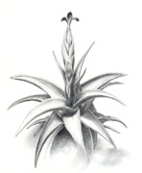
9-11 Wellbank Street,
Concord, NSW 2137

Free entry – and bring a box

- EFTPOS - Visa, Mastercard, debit cards
- Books and fertilizer for bromeliads also available
For more information please contact:
Garry Flemming – 0265539868 / 0413178884
Peter Tristram – peter@bromeliads.com.au

